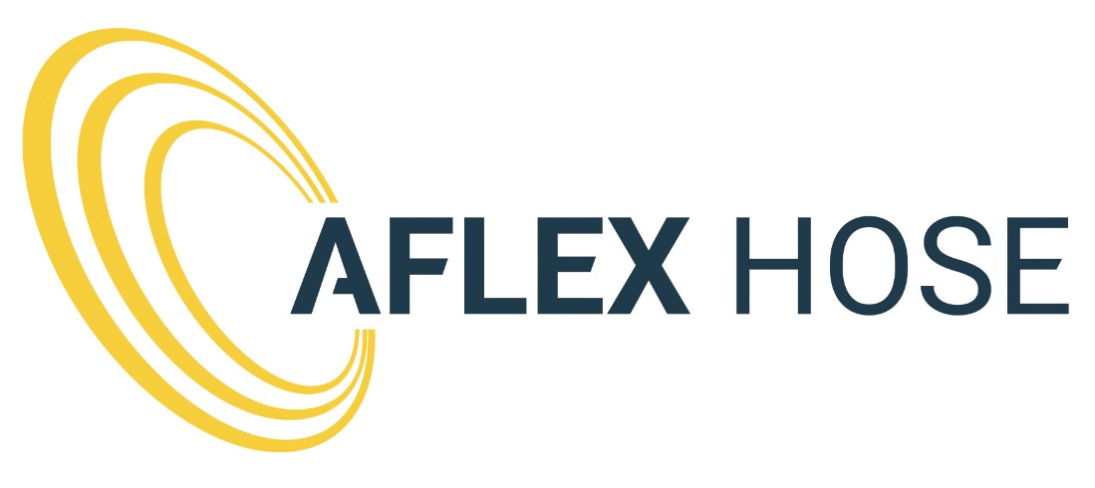

RECRUITMENT PACK

PRODUCTION OPERATOR (BRAID - BRIGHOUSE)

Contents

- About us
- The role
- Personal Specification
- How to apply
- Benefits and package

1. About us

For more than 40 years Aflex Hose has been inventing, developing and manufacturing the widest, most technically advanced range of PTFE lined flexible hose products in the world.

Pharmaceutical, Biotech and Chemical companies have standardised on Aflex Hose’s patented products as the best designed and most reliable choice for process fluids transfer in their manufacturing plants worldwide and more than 10 million cars, ATVs, trucks and motorbikes on the roads today include one or more Aflex PTFE hoses.

From raw materials to finished hose assemblies, our hoses and end fittings are manufactured at our factories in the UK and the USA.

This total control of manufacturing and design gives us an unrivalled ability to meet our customers’ specific needs, whatever the industry or application requirements.

Aflex Hose are now proud to be part of the Watson-Marlow Fluid Technology Group.

2. The Role

Main Job Function
The purpose of the job is to ensure that quality products are produced, in a manner in keeping with Quality, Safety, Health and Environmental policies and procedures of the company.

Detailed Tasks
- Winding of Braid Material
- Braiding of PTFE Tube and/or other materials
- Reeling up Hose and or other material
- Adhere to correct procedures at all times
- Ensure that all documentation is correct and completed on time
- Ensure the correct Quality controls and measurements are adhered to
- Adhere to safe working practices at all times
- To perform the necessary safety checks to ensure the integrity and effectiveness of the department and to operate in a manner conversant with the training given
- Ensure adherence to 5S in the department
- Transfer to other areas of the department/company as and when requested
- All other related aspects of the department.
- Ensuring compliance with the Company Health & Safety and Environmental Policies.
- Ensure that the department’s machines are kept in good working condition.
- Ensure the Materials Stored/Used within the department are fit for purpose.
- To work on any Task/Project assigned to.

3. Personal Specification

Essential
- Must have Production/Factory experience
- Highly motivated able to work as part of a team, flexibility required to cover sickness holidays overtime etc.
- Must possess positive working attitude
- Ability to learn quickly
- Quality orientated
- Good level of numeracy and general education
- Ability to work well as part of team and communicate with other workers
- Ability and willingness to perform manual work
- Basic computer skills, Maths and English
- Must be a team player

Desirable
- Previous experience within mechanical engineering, extrusion, injection moulding, and an understanding of pressure and flow would be an advantage.
- Technical Ability

4. How to Apply

To apply for the position of Production Operator, please forward your CV and a cover letter explaining why you think you are the perfect fit for this role to the HR team on recruitment@aflex-hose.co.uk, or to HR, Aflex Hose Ltd, Spring Bank Industrial Estate, Watson Mill Lane, Sowerby Bridge, HX6 3BW.
Please note, if you have not heard back from us after 6 weeks of applying, then please consider yourself unsuccessful. Due to the amount of applications that we receive, we are unable to contact unsuccessful candidates.
For any further information on Aflex Hose Ltd, please visit our website – www.aflex-hose.com.

5. Benefits and Package

The hours for this role are 37.5 hours per week. Monday to Thursday 8.00 a.m. to 5.00 p.m. and Friday 8.00 a.m. to 1.45 p.m. based at our Brighouse site.

Aflex Hose recognises that our people are an important asset to the business, which is why we have invested in our benefits package to assist in rewarding our people.

From day one, you will be entitled to receive a competitive annual leave entitlement and life assurance. Following successful completion of your probation review, you will then be entitled to receive Sovereign Healthcare and the option to join the generous pension scheme.

